R.U. Crazy

Rutgers and Soccer Merchandise

Project Specifications

Alexio Mota

Hua Yang

Brian Lee

Lawrence Levy

Angela Hon

Jesse Cohen

11/1/12

# **Table of Contents**

1. Project Specification pg. 3
2. Mockups pg. 8
3. Release Timeline pg. 15
4. Testing Plan pg. 17
5. Appendix pg. 18

**Project Specification**

RU Crazy is constructing an e-commerce business that will extend RU Crazy’s existing business to a broader consumer basis, allowing RU crazy to compete at a similar level with major retailers like Macys, Dick’s Sporting Goods, Sport Authority, and Barnes and Nobles’ RU Bookstore.  As a small local business, RU crazy currently only appeals to local consumers of the Rutgers area.  Consistently overshadowed by bigger and major retail corporations and businesses, the online business will allow RU Crazy to become recognize to those outside of the Rutgers locations.

The new online store will provide a new experience for existing customers of ours, allowing a more efficient way to shop our apparel and merchandise. Browsing and purchasing our products will be easier for customers, cutting down time and expenses to travel to our physical store.  This will help customers, especially those of distant from our stores, to continue shopping with us no matter how far they are located.  Products and prices will reflect those offered in-store, providing customers with the same low prices and high quality products.  Our online store will provide a new option for consumers who are looking for Rutgers merchandise and apparel, offering our competitive prices and personalize services.

The newly implemented e-commerce business will allow the company to reach a greater audience, gaining more customers and increasing business. With many competing retailers that operate online stores, it will provide more options for consumers.  The impact of  the introduction of our website will intensify price competition within the market. However, to our advantage, since RU Crazy already offers lower prices than competition, consumers will option to buy from us.  Our website and business will be recognize ss customers are comparing prices amongst our competitors and us, they will notice our lower prices, opting to buy from us instead.

The e-commerce business will allow our customers to cut down on travel time and cost, as we offer a flat rate and a efficient delivery system. It will also provide a better shopping experience as the website acts as an online catalog.  Customers will have an easier time browsing through the selection of apparel and merchandise, as they can view what’s available. The online business will act as a 24/7 store, allowing customers to access and purchase products whenever they would like.

The website will contain the following functionalities:

1. User Login/Registration: Users/customers should register with RU Crazy, providing them a more personal and efficient way to shop on our online store. User accounts will store shipping, billing information, and credit card information, as well as the user’s purchase history. This will allow a more efficient and faster checkout for users when purchasing items.  Users will be able to fully manage their personal information, enabling them to add, delete or modify information if necessary. All information will be stored in our database.
2. Shopping Cart:Shopping cart will list out the products that customers want to purchase. The shopping cart will reflect the real-time cost of what the customer will pay, which would include promotion/sale prices, tax, shipping and total amount. The cart will list out the product name, size/color, and price. Customers will be allowed to change quantity, as well as deleting products they no longer desire to purchase.
3. Checkout and Payment Process: This is the function that will allow customers to input their billing/shipping information and payment options.  Customers will be able to officially claim and pay for their items.  Cost and total amount of the products that customers are purchasing will reflect cost shown in shopping cart. The checkout function is a secured processed as sensitive and personal information is input into our database.
4. Product Catalog/listing: This function will list out the available products that customers can purchase. This function allows users to get an overview of what is on sale. This feature is an advantage for e-commerce, as customers are able to find and filter out products that may interest them. Clicking on the products that are listed will route the customer to a more detailed and descriptive page of the product, also allowing them to choose size, color and to add to their cart.
5. Search: Customers will be able to type in a keyword in the search bar which will cross reference with our store’s database. The results will display products that show relevance to the customer’s search preference.

Flow of operation:

1. Define operational requirements.
2. Build operational work instructions.
3. Plan operational work.
4. Execute operational work.
5. Maintain operational work instructions.
6. Manage operational work.

User Roles/Privileges:

* 1. Guest Users:
     + Ability to view the webpage
     + Ability to add items to cart
  2. Login Users:
     + Ability to view the webpage
     + Ability to add items to cart
     + Ability to checkout
  3. Editors:
     + Ability to edit the webpage
     + Access to some levels of the database: Data (select, insert, update, delete), Structure (create, drop, index, alter)
  4. Administratives:
     + Ability to edit the webpage
     + Access to all levels of the database: Data, Structure, Administration

Our website will be written in PHP which can be done using programs as advanced as Dreamweaver or as basic as Notepad. Our website will use a MySQL database for all of the tables. There are many different options for this but our website most likely will most likely be run on an xampp server. The easiest way for our website to process credit card orders would be to use paypal because its one of the cheapest ways and very secure. Using paypal will also allow our website to have a shopping cart feature.

Our website would need several database tables to run smoothly. The website would need a database table specifically for the customer logins. This would save the usernames and passwords of all the customers. There will also be database tables to store all of the different customers information, such as addresses. There will probably be a separate database for the administrator login. The website will have a database set up for all of the stores inventory, each type of inventory will have its own table. For example, clothing, tailgating accessories, hats, watches, ect. will all be separate. Each of these categories will also be separated into sub categories, such as mens, womens, or children. There will also be a table set up for the out of stock items.

Our website will be designed so that we can deliver our services to as many potential customers as we can. Browser support plays a major role when it comes to any e-commerce website.  RU Crazy’s website will be fully available on the following browsers: Google Chrome, Mozilla Firefox, Opera, Safari, as well as Internet Explorer 6 to 9. We believe that every customer is entitled to getting the best web experience when shopping online, therefore we feel that it is a must to cover all of the most popular browsers used today.

Our website will be designed to handle many transactions at once.  There will probably be many visitors on the site and once and we want to ensure that everyone’s transaction can be executed at the same time so that people do not have to wait.  We also do not want a user’s transaction to time out and we do not want them wondering if their credit card information was processed or not.

**Mockups**

The RU Crazy website will start out on a homepage where it will present advertisements of current promotions throughout the website and the store.  There will be different pages which include men’s clothing, women’s clothing, and various other pages.  The site will also show what brands we carry and different sales that we are having.  You will also be able to track your orders and find our locations through our website.  In addition to just having a website, we will also have a Facebook page and a Twitter to help promote our business.  Links for these will be found on our website in the lower right hand corner.

Website Mockups:

1. Home Page: 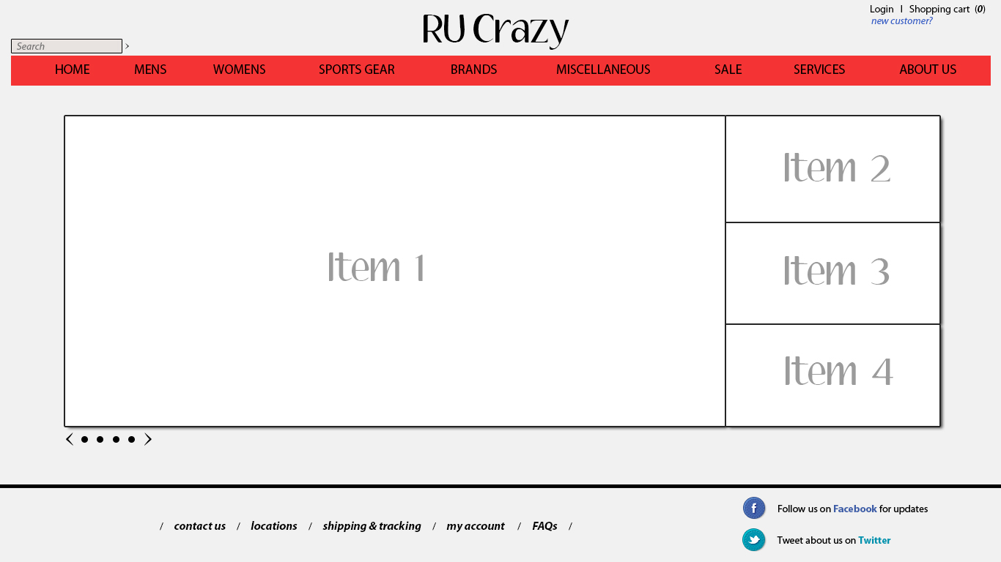
2. New Member Registration Page:

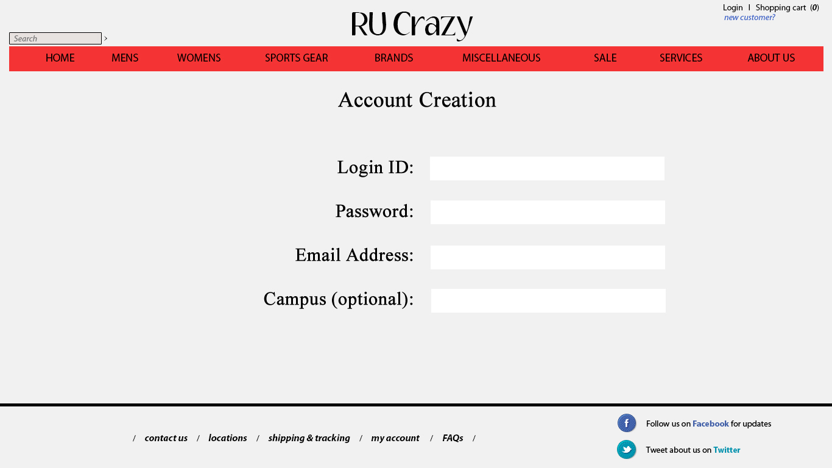

1. Returning Member Login Page

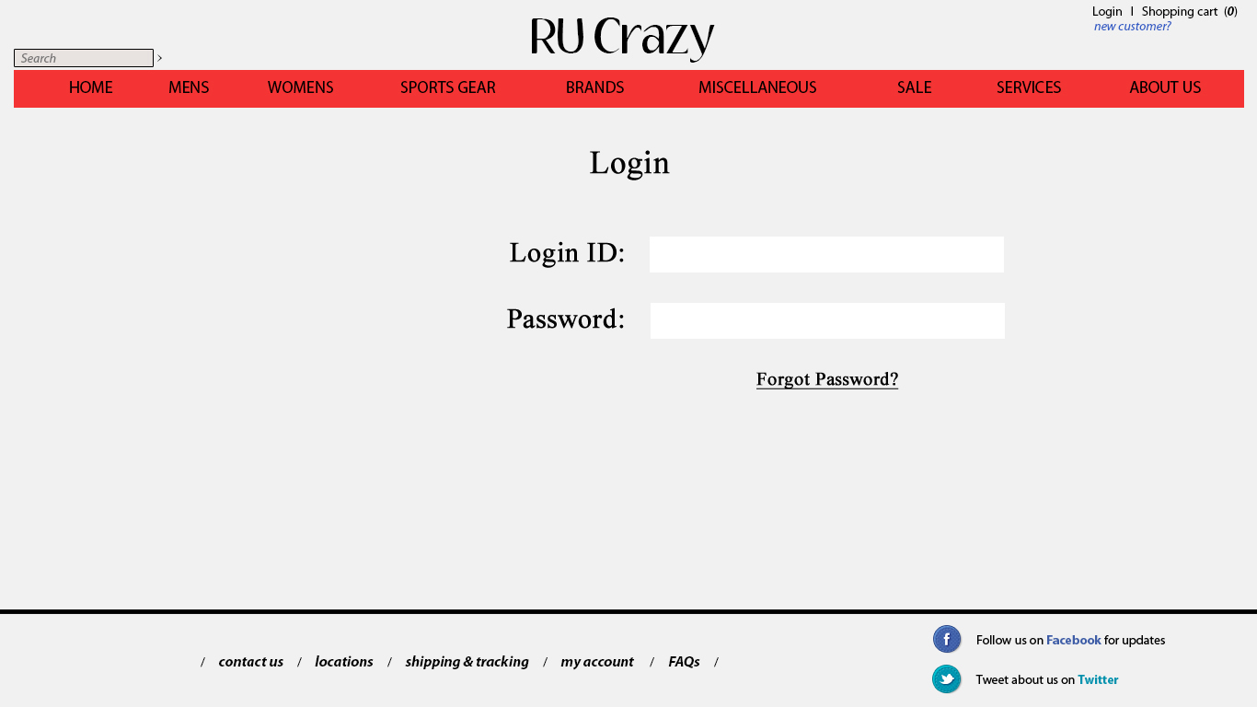

1. Member After-Login Page

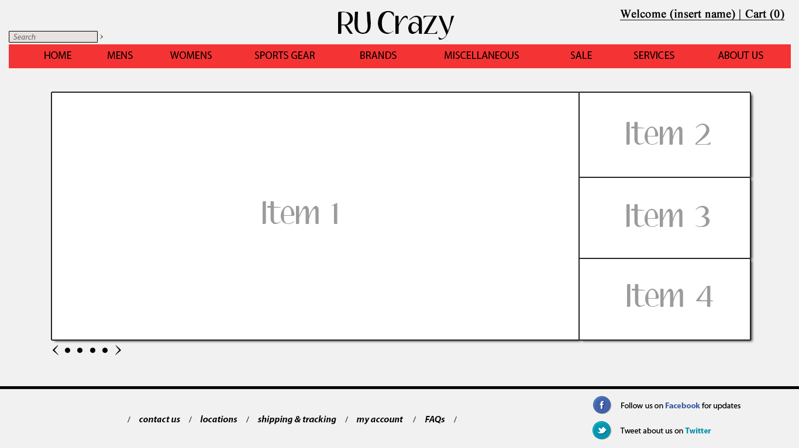

1. Non-Member Place Order Page

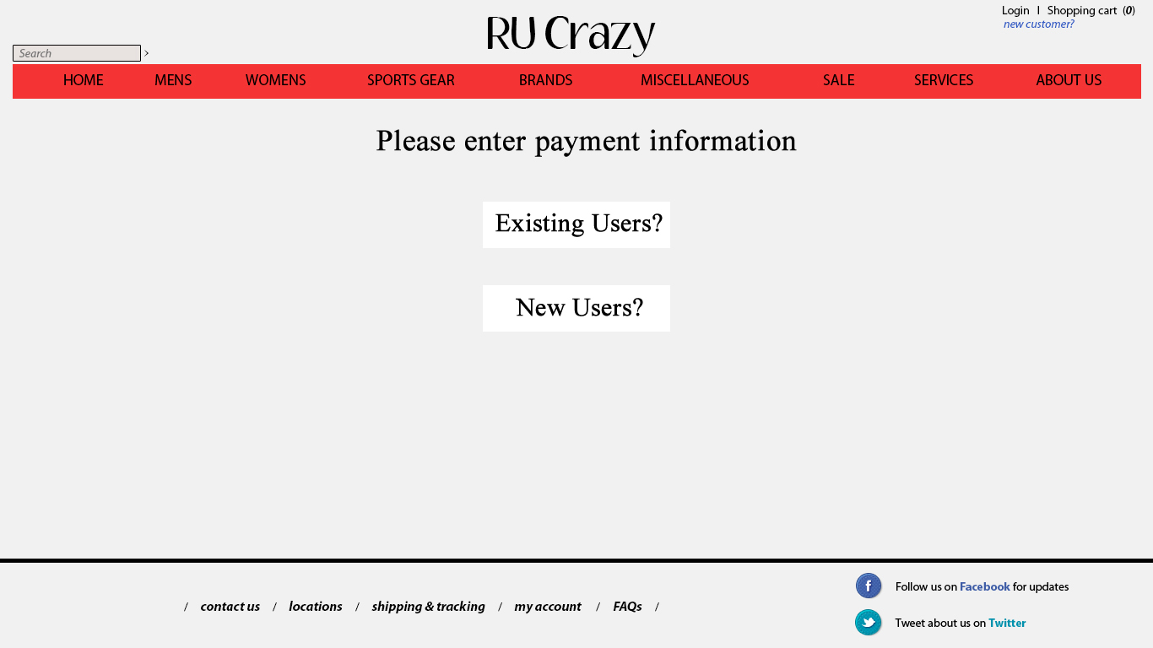

1. Goods Information Page

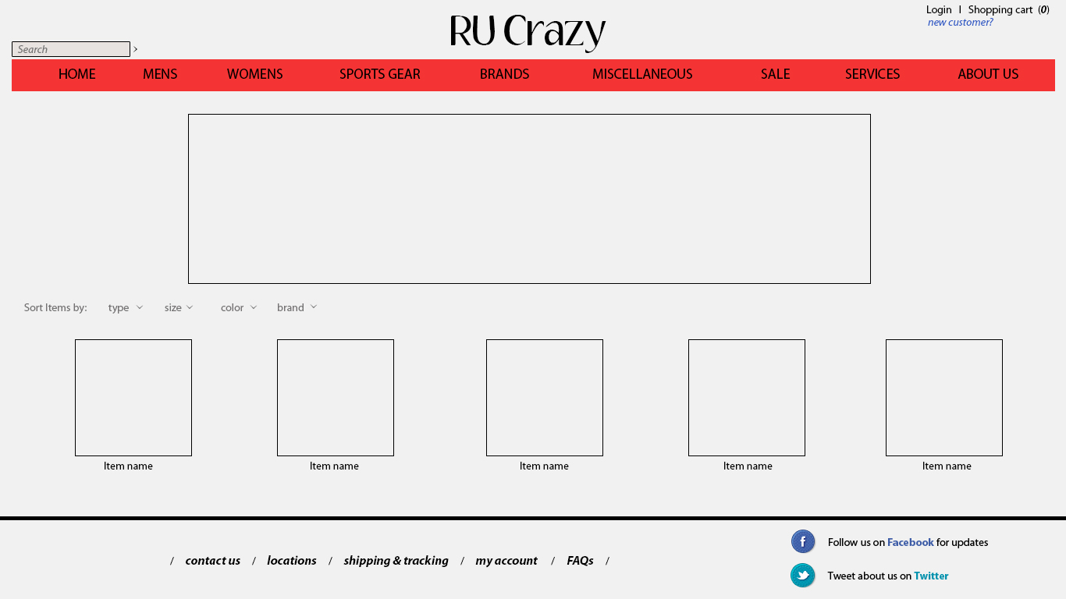

1. Credit Card Process Page

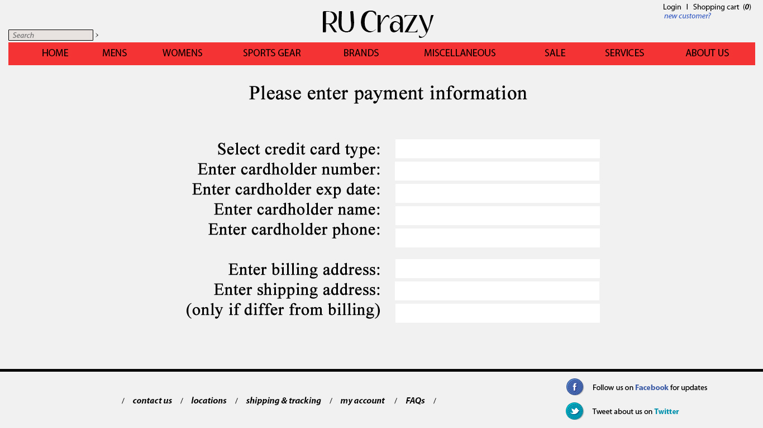

1. Order Completion Page

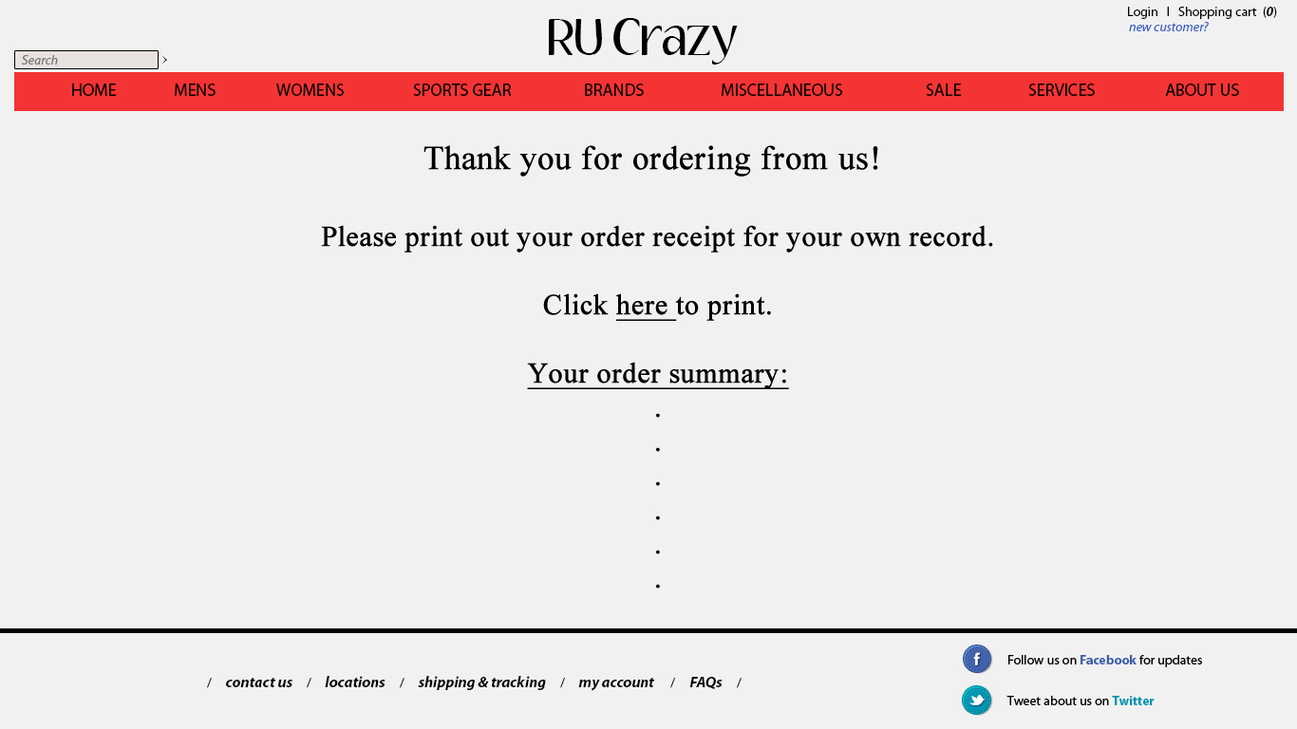

1. Seasonal Promotion Page

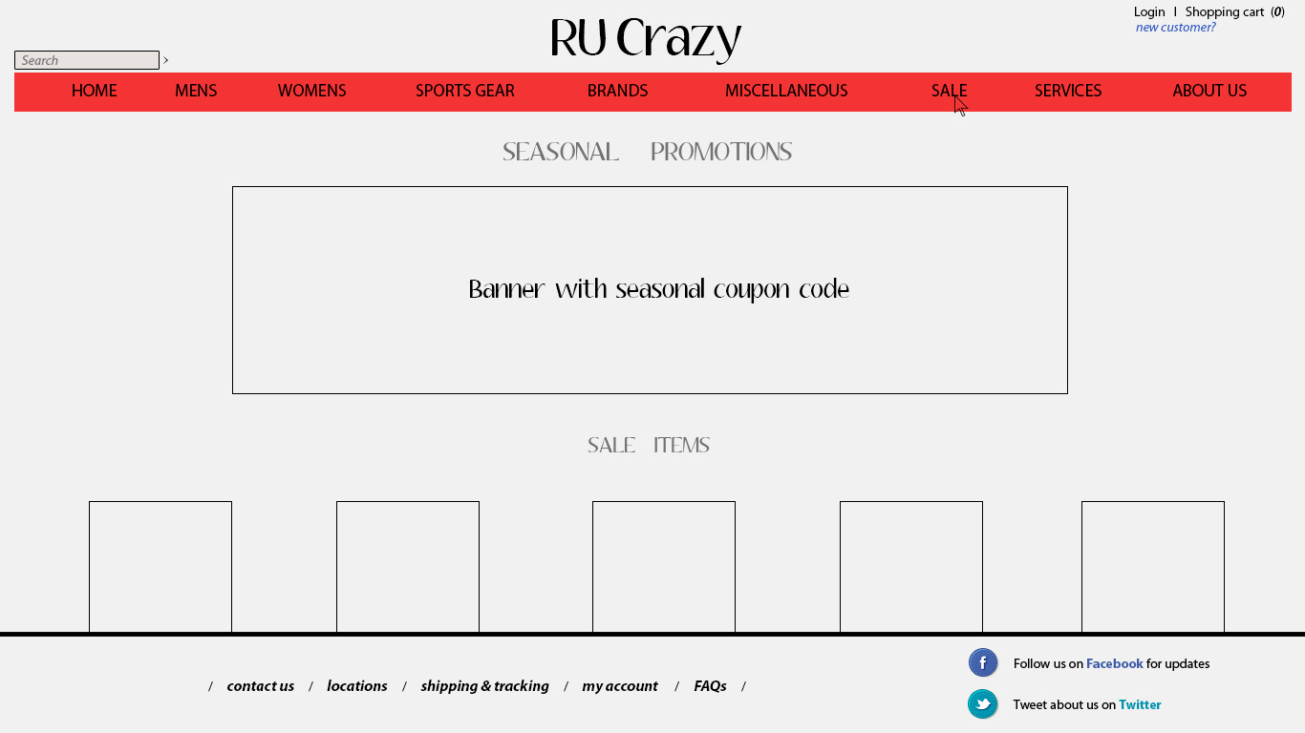

1. Store manager Login Page (Same as User Login)



1. Store Manager After-Login Page

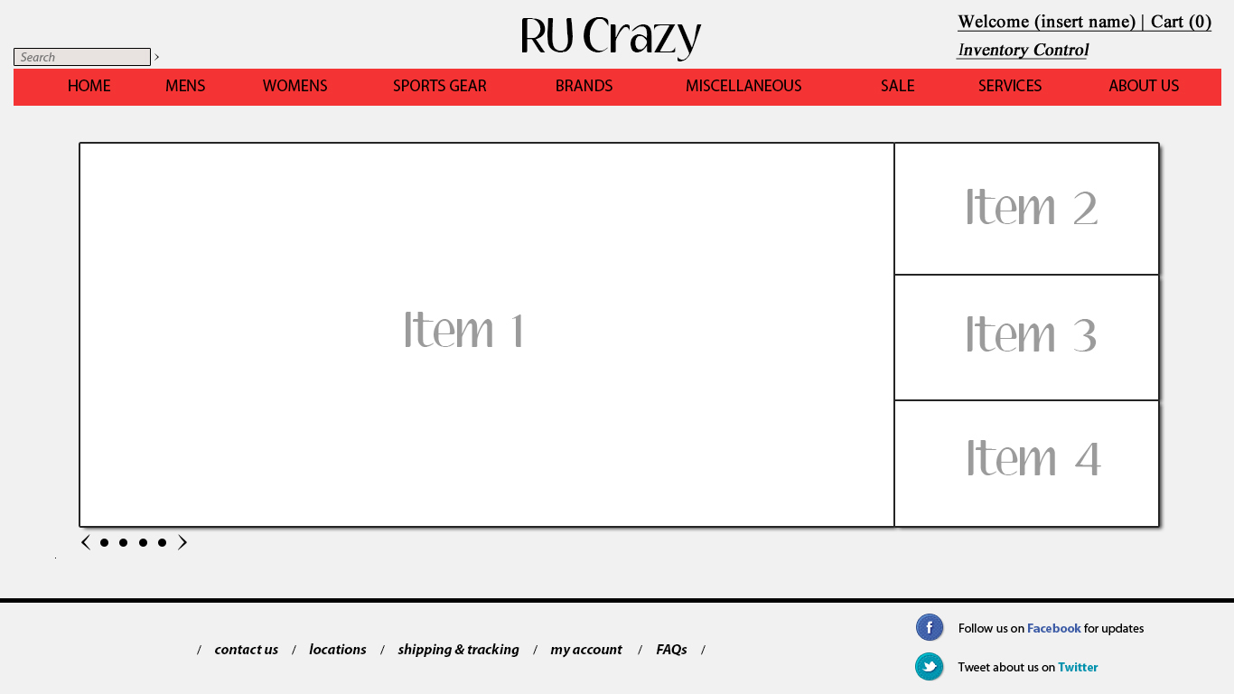

1. Site Administrator Login (Same as User Login)



1. Site Adminitrator After-Login Page



1. Inventory Control Page

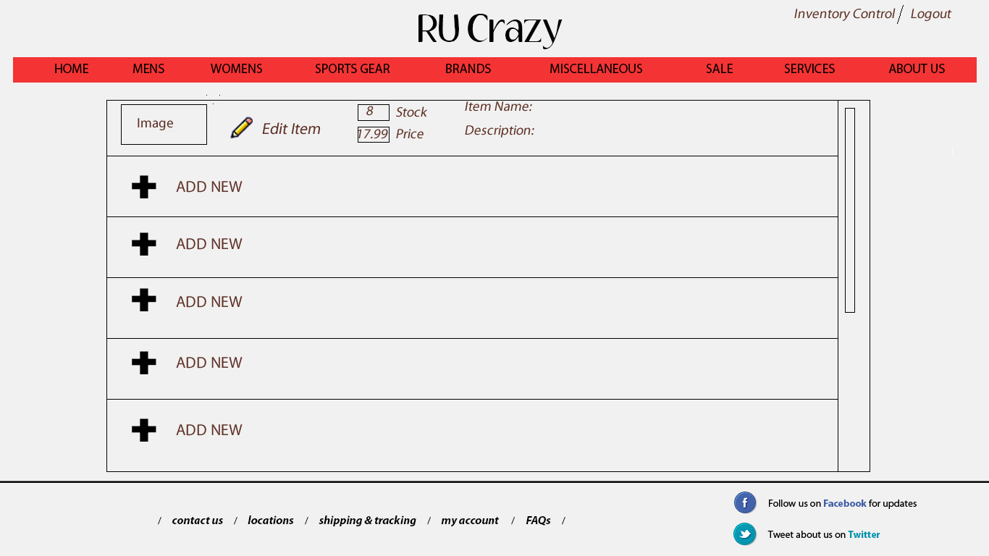

**Release Timeline**

The first phase of our release is the pre-alpha phase.  During this phase, we will be coming out with many developmental builds daily.  After we have successfully completed the pre-alpha phase, we will move onto the alpha phase where we start testing it out to make sure everything works.  After the alpha phase, we will move onto the beta phase and invite a limited amount of people to try our website.  Once we are confident with our beta product, we will move to the release candidate phase.  This phase will consist of the gamma and delta phases in which we will improve our website even more.

After we have completed these phases of the project, the next phase of the project is the release to the manufacturing/marketing step.  This is when we will really see the growth of our website.  Giving our website to the marketing team will enable us to reach a wider audience and make our website well known.  After we have given our website to the marketing team, we will make our website available to the public and promote a live release of the website.

* 1. Include list of functions for each release
  2. Reasonable dates of each release
  3. Sample of the release document

**Testing plan**

The success of our website will be defined by a few factors.  The first and most important value of success will be the number of unique visits to our site.  This criteria will measure how many different people come to the site.  This is helpful in that we are keeping track of new users.  Ideally, our website should keep generating new users in addition to keeping the old ones.  Another measure that we would use to measure our success is by measuring how many orders get placed through our website.  This measure combined with the last will provide an understanding of how many people that come to the site will actually place an order.

In addition to these measures of success, page ranking is a very important measure as well.  Page rank on popular search engines such as Google, Yahoo, and Bing show the popularity of a website.  By striving to be at the top of search results (when searching for Rutgers clothing or other related searches) will increase our popularity and will give people another option for purchasing anything Rutgers related.

In order to ensure the website is functioning perfectly we will run test cases that will demonstrate normal customer interactions with the website. The most basic tests will be ensuring proper rendering on all browser and platform types. This will also include testing on different screen sizes. Once we are sure our website will render properly across all browsers, screen sizes and platforms, we will move onto making sure all of the aspects of the website are working properly. This means checking all links are working, all images are loading, anything that is on the website will be tested for functionality. Next will be ensuring that the shopping cart function works and the credit card processing is working properly. This phase will also include making sure our error pages show up when needed and the report is sent to us.

The results of the tests will be printed out in charts and tables that detail every action that was done and the outcomes. The reports will be color coded, showing properly working functions in green and anything that is not working properly in red. Whatever is not working properly will also print out a detailed explanation of what should have happened and what actually happened.

Appendix

* Empty At the Moment